**04-07-2023**

**OOPS Concepts:**

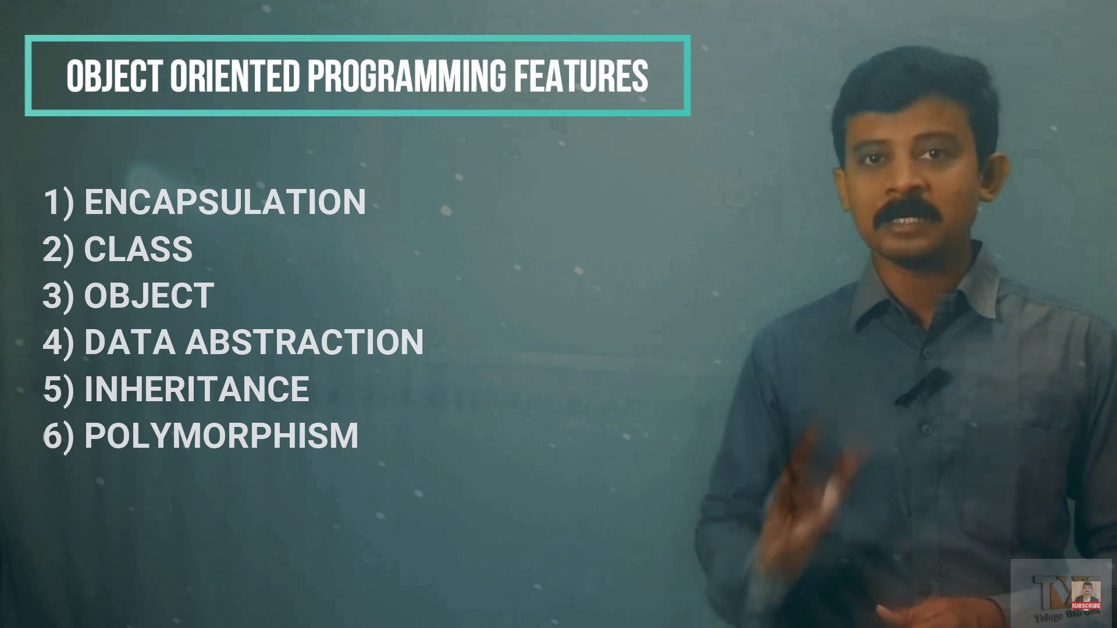

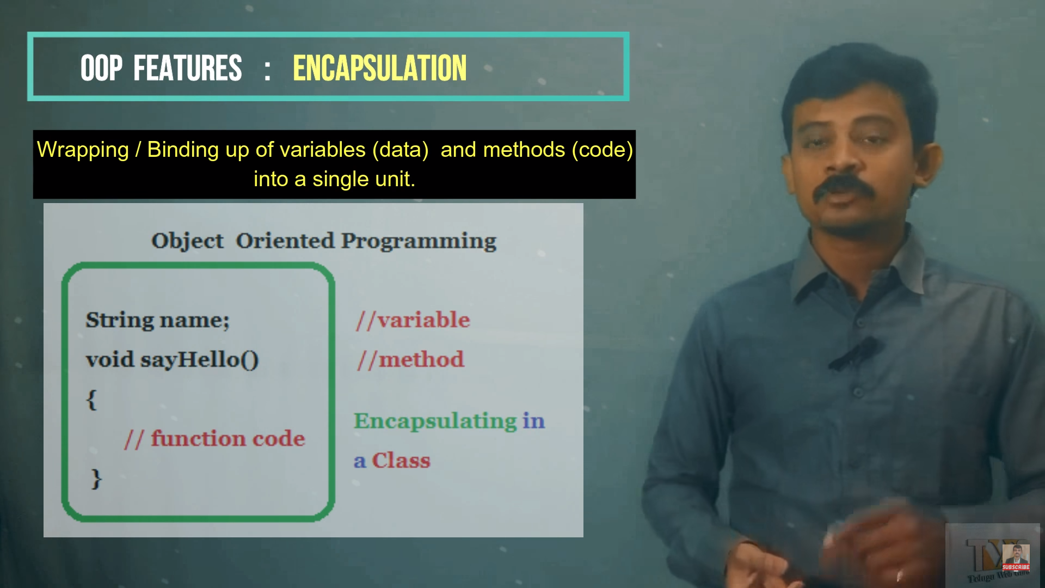

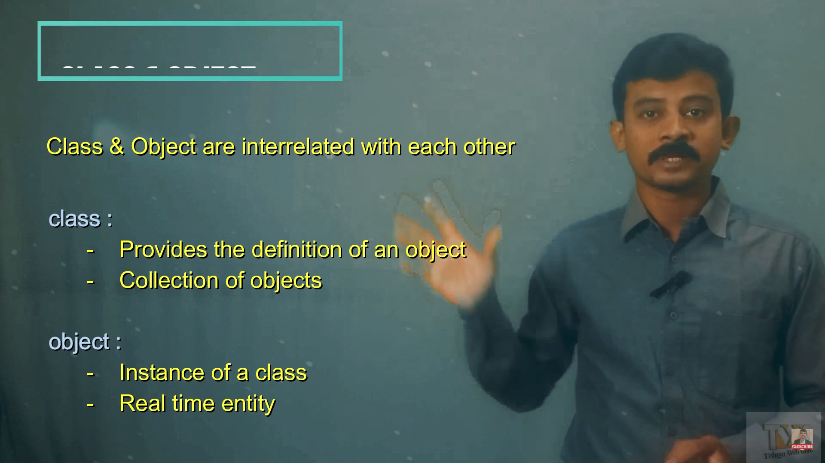



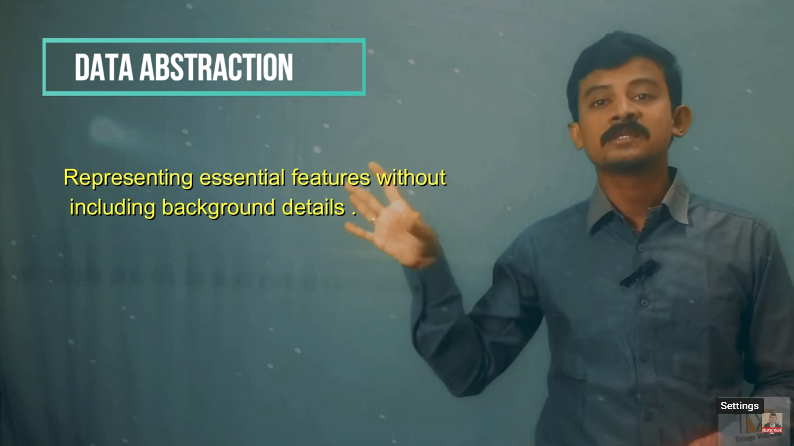





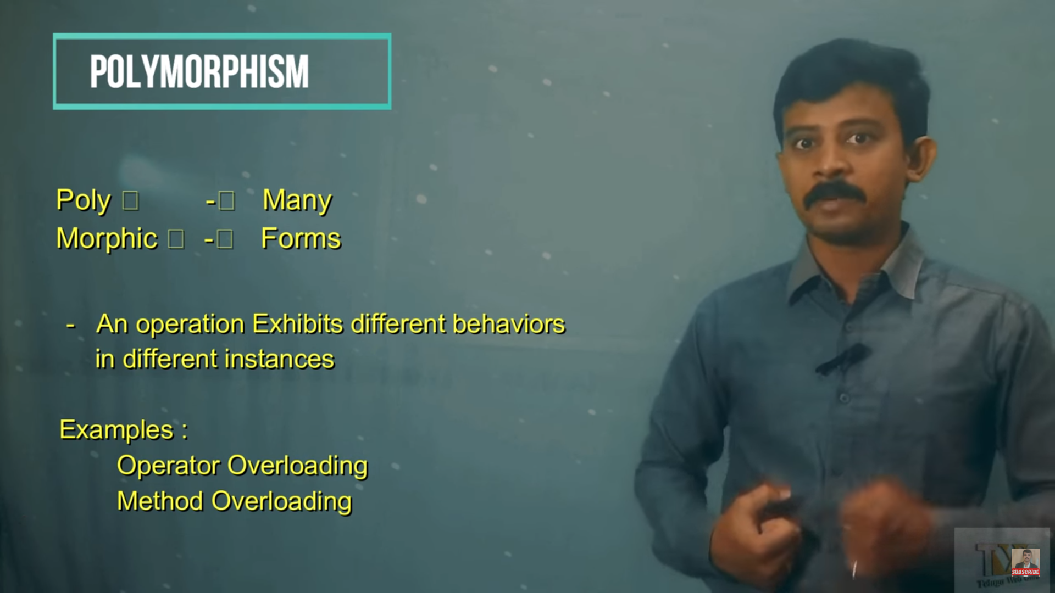

**REAL TIME EXAPMLES:**

[**https://datatrained.com/post/oops-concepts-with-real-time-examples/#:~:text=Object%2DOriented%20Programming%20(OOP)%20stands%20for%20Object%2DOriented,perform%20actions%20on%20the%20data**](https://datatrained.com/post/oops-concepts-with-real-time-examples/#:~:text=Object%2DOriented%20Programming%20(OOP)%20stands%20for%20Object%2DOriented,perform%20actions%20on%20the%20data)**.**

JAVA - code reusability while still preserving security.